QEII Case Study: Cardano Summit

The QEII Centre celebrated the return of large events by hosting one of seven two-day live events for the globally-recognised Cardano Summit. The summit, which took place on 25 and 26 September 2021 virtually and at seven locations around the world, was dubbed ‘The Biggest Blockchain Event Ever’ and welcomed 100,000 people from the crypto community and those with an interest in blockchain and finance.

Objective
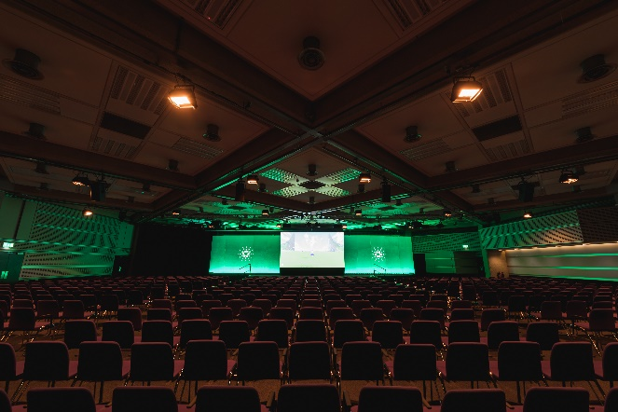
With less than three months’ notice, The QEII Centre was asked to provide a meeting space for 1,000 delegates attending the Cardano Summit – a two-day hybrid immersive event for the crypto community.

The Cardano Summit is traditionally held in the US with delegates flying in from across the globe to attend. However, with travel still restricted in some regions, organisers Input Output, needed to find a way to bring delegates together without them travelling outside their nations.

It was therefore decided to hold the event virtually, attracting 92,000 attendees, while also providing a live element, so seven locations around the world – London, Wyoming, Miami, New York, Berlin, Cape Town and Tokyo – each hosted 1,000 people and a further 50 community meet-ups hosted approximately 100 people each.

As well as supplying conference and breakout spaces, QEII was required to give high-level AV support and served refreshments and lunch to fuel the 1,000 delegates attending the talks, presentations and demonstrations from Cardano leaders and luminaries over the two days.

Execution
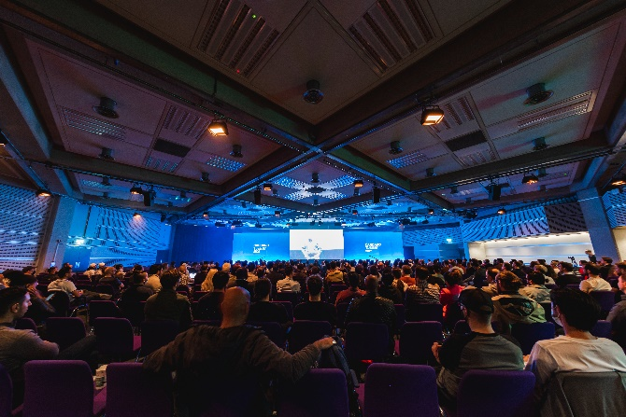
The centre’s third floor Fleming and Whittle rooms, which offer stunning views overlooking the Houses of Parliament, Westminster Abbey and the London Eye from their double height windows, were set up for the main conference space where 1,000 delegates could view the same content being delivered to those attending virtually and delegates attending in-person around the globe.

QEII’s in-house AV team, QEII Live, provided all AV support and a high bandwidth to ensure virtual content was streamed seamlessly to delegates and support the immersive elements of the event. The QEII Live team worked with a gaming company who Input Output had commissioned to provide a gaming component to the conference with each delegate offered the chance to each create a turtle avatar which appeared on screen at a certain point in the day.

The client also required a meeting room that could host 100 people for a hackathon, so QEII’s flexible and light Rutherford and Moore rooms on the fourth floor were joined together for this purpose.

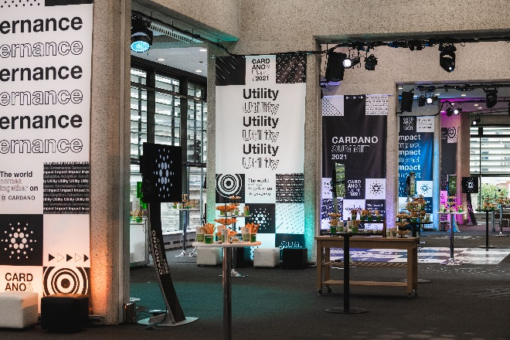
QEII’s in-house catering team QEII Taste provided refreshments on arrival and lunch on both days from the Britten, also located on the third floor, allowing delegates to refuel with ease.

To highlight the global nature of the event, food was creatively themed according to the style of cuisine typically served in the seven live locations. Dishes, which were served from food stations, included Katsu curry with steamed rice (Tokyo); Hot dogs with sauerkraut (Berlin) and Billingsgate fish pie (London).

There was also a bar serving up an array of soft and alcoholic drinks to delegates.

Results

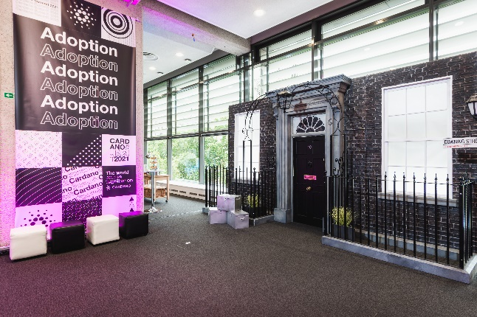
The client ‘loved’ QEII’s large, flexible space with state-of-the-art AV, which could accommodate the large number of delegates and meet their virtual needs. Having access to QEII’s expert AV staff and high-quality catering within a central location at such late notice for an event of this size was also welcomed by Input Output.

Client said: “The location is perfect, and the meeting space was exactly what we needed for the event.

“Everything was great and holding the London event at QEII improved the outcome as we had enough space to accommodate the attendee numbers we were expecting.”

